CHMY 271

PRACTICE EXAM I ANSWER KEY Fall 2012 Name _______________________

Watch your significant figures and units throughout the exam! Show your work for partial credit.

1. (12 pt) For each of the following molecules, describe the types of interactions that would likely occur with water molecules if the compound were placed in water, and predict whether it would be soluble or insoluble in water.
A) CH₃CH₂OH B) CH₃CH₂OCH₂CH₃
London forces, dipole-dipole London forces, dipole-dipole, insoluble
H-bonds, soluble

C) I₂ D) (CH₃CH₂)₄N⁺
London forces, soluble London forces, ion-dipole, soluble

2. (4 pt) Describe what London forces are in your own words. Because the electrons in molecular orbitals are not in fixed locations and they can be anywhere within their orbitals, there will be moments where they spontaneously shift to one side of a molecule creating a greater amount of negative charge on that side of the molecule and leaving a partial positive on the other side of the molecule. The molecule becomes polarized even though there is no difference in electronegativity pulling the electrons to one side. The larger the electron cloud around the molecule, the greater its ability to become polarized in this way and the greater amount of partial charge will form giving it the ability to form stronger London forces. Polarizability is the tendency for a molecule that’s normally nonpolar to become polar by shifting electrons. London forces are temporary though, because the electrons shifting is based on chance and is temporary, so London forces are often weak overall.

3. (5 pt) Write in any formal charge on the appropriate atom(s) in the following structure.
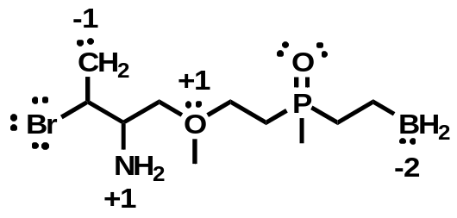

4. (4 pt) List two requirements for a molecule to have a permanent dipole moment. It must contain two elements that have different electronegativities and are covalently bonded to one another. It must also have an element of asymmetry so that the dipole in one direction is not cancelled out in the opposite direction.

5. (4 pt) Explain using molecular orbital theory and entropy why diatomic helium is not found in nature.
The figure illustrates that upon bonding, two of the electrons become more stable (lower in energy) when they enter into the bonding molecular orbital. However, the other two electrons become less stable (higher in energy) by an equal amount when they enter into the antibonding orbital. The energy gained is equal to the energy lost, so whether the He atoms bond or not, there is no OVERALL difference in energy. Because energy does not favor either state (bonded or not bonded), entropy must be the deciding factor. Because there is much more disorder when the atoms are not connected through a bond, entropy greatly favors the unbonded state.
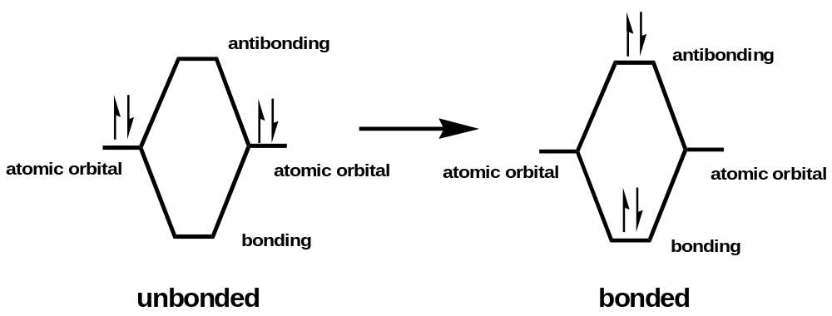

6. (5 pt) Draw the CH₃⁺ molecule using the appropriate hybrid molecular orbitals. Label the orbitals with the appropriate hybrid orbital notation and indicate whether they are sigma or pi bonds. Show any unhybridized p orbitals, and indicate the location of all of the valence electrons in the molecule. We know that in CH₃⁺, there are three atoms equally bonded to the central carbon atom. Because the three H atoms are all equivalent, they must be bonding through orbital overlap with three equivalent orbitals. We also know that the C has a +1 charge, which means that it has one LESS electron than it normally has as a neutral atom. Thus, the carbon in its unhybridized state has three valence electrons in its 2s and three 2p orbitals, shown in the figure below. The 2s and three 2p orbitals must be used to create three equivalent hybridized orbitals with one electron in each for overlap with the three H atoms. To make THREE equal orbitals, only THREE orbitals can be combined (the 2s and two of the 2ps). That leaves one of the p orbitals unhybridized, while the other two p orbitals will hybridize with the 2s orbital to create three sp² orbitals with one electron in each.
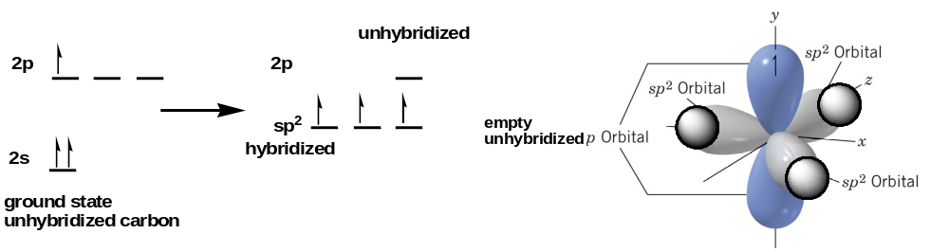2

Part B. Give the steric number and molecular geometry about the central atom of CH₃⁺.
The central carbon has 3 electron groups around it (three bonds and zero lone pairs), so it’s steric number is 3. That means its electron group is trigonal planar. Because all three electron groups are bonds to atoms and there are no lone pairs, the molecular geometry is also trigonal planar. All three atoms that are bonded to the central carbon are in the same plane spread out as far from each other as possible.

7. (8 pt) Draw both a line representation and a 3D representation using wedges for the following molecule: (CH₃)₂CHCH₂C(OH)₂CH₂CH₂COH.
The line representation is 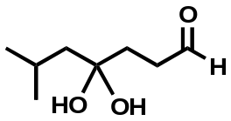
The 3D wedge structure is 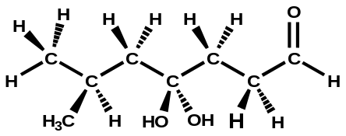

8. (9 pt) Label all of the functional groups in the following molecule.
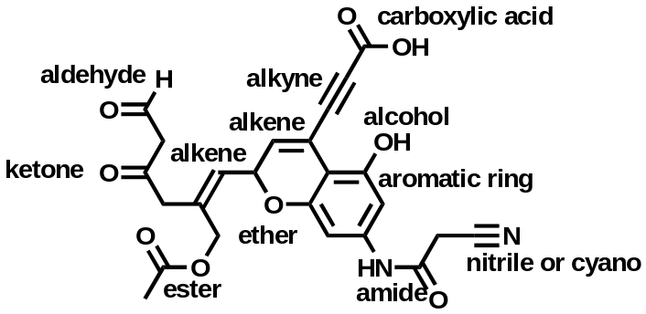

9. (14 pt) Draw ALL resonance contributors for the trans isomer of HOCH=CHNO₂. Label each as either a major or minor contributor. Draw the best resonance HYBRID you can. Show all formal charge in each contributor and in the hybrid.
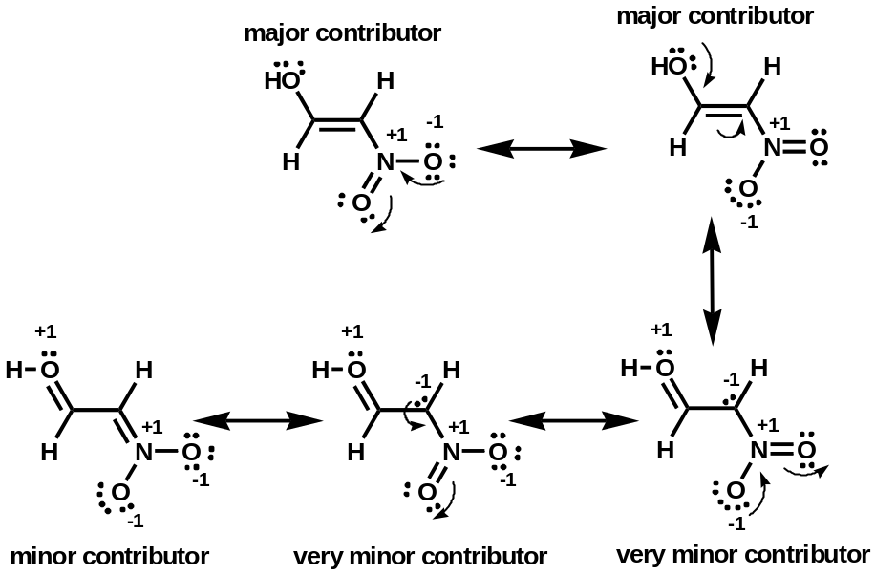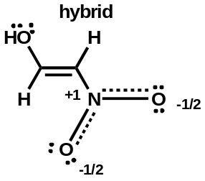

10. (4 pt) Describe the guidelines for drawing curved arrows to show how electrons flow in a chemical reaction. Arrows flow from negative charge to positive charge, because they represent movement of electrons. The arrow must always start on a pair of electrons, and it must always end either on an atom (if the electrons are to become a lone pair on that atom) or between two atoms (if they are to become shared in a covalent bond. A full-headed arrow represents a pair of electrons moving. A half-headed arrow represents a single electron moving. Electrons may not move more than one atom away from their original location.

11. (5 pt) Give an example of a molecule that can act as a Lewis acid but can not act as a Brønsted-Lowry acid. Show the molecule reacting with any Lewis base. To be able to act as a Brønsted-Lowry acid, a molecule must contain a proton (H atom) that can be easily lost when a pair of electrons attracts it. A Lewis acid is also attracted to a pair of electrons, but with an atom other than Hydrogen.
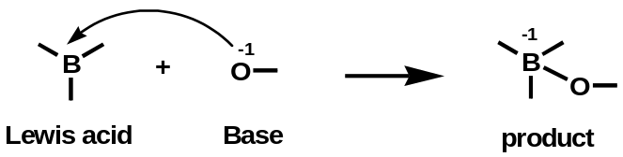
The Lewis base is often said to donate a pair of electrons, however it can more accurately be said to share a pair of electrons with the Lewis acid. The product contains a bond between the two. The electron pair is NOT transferred.

12. (12 pt) Rank the following compounds in order of increasing acidity or by decreasing pK_{a}. Fully explain your ranking.
Strongest HI, HCl, HCO₂H, CH₃OH, NH₃, CH₄ Weakest
The strongest acids are those that produce stable conjugates. HI and HCl are the strongest because the conjugate bases that form, the halides I⁻ and Cl⁻, are relatively stable ions. HI is the strongest, because I⁻ is a larger ion and can spread out the negative charge more effectively than Cl⁻. The instability of the negative charge on I⁻ is not concentrated to as small of an area as it is in Cl⁻. When HCO₂H and CH₃OH act as acids, they both produce a formal negative charge on an oxygen, which is less stable than on a halide, so HCO₂H and CH₃OH are not as strong as HI and HCl. However, when HCO₂H acts as an acid, it has resonance that spreads out the negative charge of the oxygen with the other oxygen in the molecule, so the individual negatives are ½ rather than the full negative that forms when CH₃OH acts as an acid. Because CH₃O⁻ does not spread the charge out, it is lass stable, and CH₃OH is weaker than HCO₂H. NH₃ is the next weakest, because it forces a negative charge on N when it acts as an acid and loses a proton. The negative charge on N is less stable than on the O, because the N has fewer protons with positive charge in the nucleus to stabilize it. Finally, CH₄ is the weakest. To act as an acid, a very unstable negative charge forms on C. C has even fewer protons in its nucleus to balance the negative charge that forms. As acids become stronger their pK_{a} values decrease.

13. (5 pt) Give a reaction mechanism using arrows to show the movement of electrons for the reaction between acetic acid and water to produce hydronium ions and acetate ions. Does the reaction involve heterolytic or homolytic cleavage of the bonds?
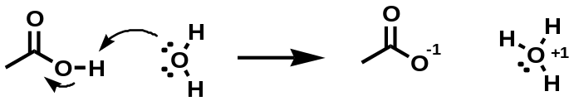

14. (4 pt) Explain in detail why benzoic acid (C₆H₅COOH) dissolves readily in aqueous sodium hydroxide but only sparingly in distilled water. Benzoic acid contains a fairly large aromatic benzene or phenyl ring, which only undergoes weak London force attractions with water. The carboxylic acid portion of the molecule can form stronger H-bonds with water molecules, but it is more preferable for water to stick with other water molecules instead, because each water molecule can form many H-bonds readily with the other waters around. When it remains undissolved, the waters are not forced to give up H-bonds they have with one another in order to undergo London interactions with the aromatic ring of the benzoic acid, so it remains undissolved. When treated with the strong base NaOH, the proton of the benzoic acid is removed to produce C₆H₅COO⁻, which has resonance to stabilize it. The negative charge of C₆H₅COO⁻ is capable of forming ion-dipole interactions with water. Such ion-dipole interactions are considerably stronger than the H-bonds that water forms with benzoic acid or even with other water molecules. The ion-dipole interactions are strong enough to cause the water molecules to interact strongly with the benzoate ions, C₆H₅COO⁻ and dissolve the ions.

15. (14 pt) PART A. Predict whether the following reactions will favor products or reactants and whether the equilibrium constant for the reactions will be greater than 1 or less than 1.

Reactants Products
A) 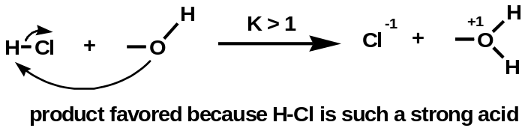

B) 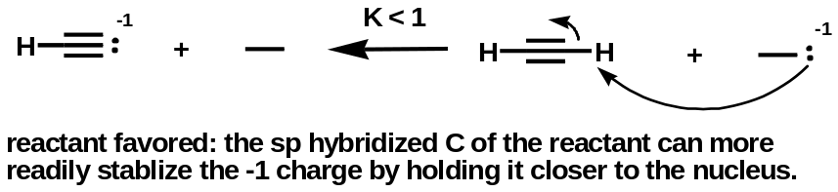

C) 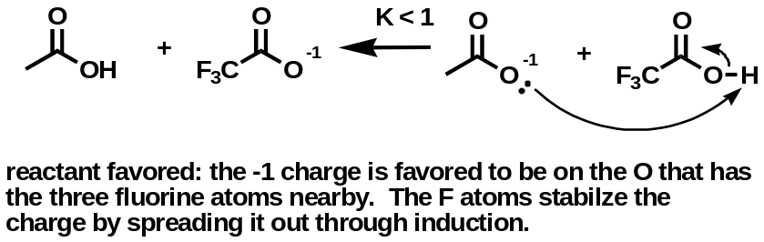

D) 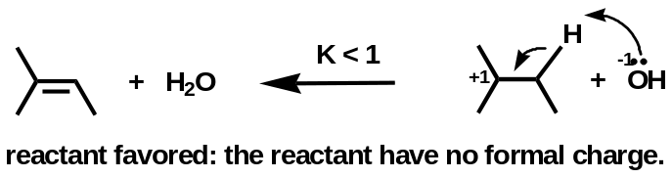

PART B. For each of the above reaction, show with curved arrows the most reasonable movement of electrons.

16. (4 pt) Explain why acetic acid has pK_{a} = 130 in the gas phase. When acetic acid acts as an acid and loses a proton, the resulting acetate (conjugate base) has a formal negative charge. In aqueous solution, the negative formal charge can be stabilized by interacting with a partial positive charge on water. Even in a nonpolar solvent, there will still be some stabilization of the negative formal charge as even a nonpolar solvent is polarizable and can undergo London forces with the acetate ion. However, in the gas phase, molecules are so spear out in general that they effectively have no interaction with other molecules. In the gas phase, the acetate ion is extremely unstable, because it has not counter balance for its negative charge. There is effectively no positive charge anywhere to stabilize it. Thus, the reaction that produces acetate ions will vastly favor the reactants in the gas phase. It will have an extremely small K_{a} = 10⁻¹³⁰, which is effectively zero. –log of K_{a} then gives the pKa of 130. The higher the pKa, the weaker the acid, and this pKa is EXTREMELY high, so it is essentially not an acid in the gas phase. This illustrates how important a solvent is to stabilizing ions that form.

